

Version 24.1.1 for Salesforce Commerce Cloud - SFRA

Upgrade Guide

# 

# 

# 

# 

# 

# 

# 

# 

# Summary

This guide describes how to integrate Cash App Payment method in your Afterpay Cartridge.  
  
We assume that you already have Afterpay Cartridge 22.0.0 or above and have Cash App Pay enabled for your Afterpay merchant.

# 

# Table of Contents

Summary

Table of Contents

Component Overview

Upgrade Guide (for v22.0.0 and above cartridge users)

Testing

Operations / Maintenance

# 

# Component Overview

## Functional Overview

For the eligible merchants, this cartridge version 24.1.1 provides both Afterpay and Cash App Pay payment options.  
  
This functionality is currently for only the US region.

## Use Cases

Allows checkout using the Afterpay and Cash App Pay payment methods at the checkout screen.

## Limitations

The following Afterpay APIs are supported.

1. Direct Capture Payment
2. Authorize Payment
3. Create Checkout
4. Get Checkout
5. Get Configuration

The following Afterpay APIs are not supported or applicable

1. Void Authorization - Merchants will need to implement this in the event that orders can be canceled from SFCC.
2. Capture Payment - If using our deferred payment flow the capture payment call will typically happen from an Order Management System
3. Update Shipping Courier - this will typically be implemented in the Order Management System.

The details about APIs for the different regions can be found here :

| Brand | Countries | URL |
| --- | --- | --- |
| **Afterpay** | **AU,US,CA,NZ** | <https://developers.afterpay.com/afterpay-online/reference> |
| **Clearpay** | **UK** | <https://developers.clearpay.co.uk/clearpay-online/reference> |

## 

Cartridge tested in :

* Compatibility mode: 22.7
* SFRA 5.3.0 and 6.3.0

## Privacy, Payment

This integration requires access to the following customer data elements:

* Billing Address
* Shipping Address
* Order Details
* Customer Profile.

No credit card details are stored within SFCC using this integration.

# Upgrade Guide (for v22.0.0 and above)

## Download the cartridge

The current version of the Afterpay cartridge is available directly from Afterpay. <https://github.com/afterpay/afterpay-salesforce-commerce-cloud>

The version hosted on the Salesforce Commerce Cloud Partner Marketplace is an older version and should not be used.

## Build Client-Side Resources

This is required in order to build the client-side css and js files that are specific to Afterpay.

* Make sure package.json contains the correct reference to the location of the SFRA base cartridge:

| "paths": {  "base": "../storefront-reference-architecture/cartridges/app_storefront_base/" }, |
| --- |

* Run the following commands:

| $ npm install $ npm run compile:js $ npm run compile:scss |
| --- |

## Import the cartridge

Import the cartridge using UX Studio. Alternatively, can also use npm run uploadCartridge, or VSCode Prophet plugin.

## Import the site metadata

For the Afterpay integration to work, the following object structures (metadata) needs to be imported and configured in the Business manager. Follow the below steps:

1. In the cartridge bundle find metadata/afterpay-meta-import folder.
2. Find the sites folder and inside it find the RefArch folder.
3. Rename this RefArch folder to the ID of your site. If you have multiple sites to which this meta has to be imported, then copy and paste this RefArch folder to replicate for other sites. Renames those folders with ID of corresponding sites.
4. In the cartridge bundle, inside the metadata folder compress the afterpay-meta-import folder to generate the afterpay-meta-import.zip file.
5. Go to Business Manager Menu > Administration > Site Development > Site Import & Export
6. Under Import: Upload Archive : Ensure that the radio button with label Local is enabled (Else click on the radio button to enable it)
7. Click on Choose File input field, select the afterpay-meta-import.zip file from open dialog box and click on upload button
8. After finishing the upload, from the Archives list click the radio button corresponding to afterpay-meta-import.zip and click on Import button
9. Click on the OK button of the confirmation box asking “Are you sure that you want to import the selected archive?”

## Upload Changes if Necessary

If you changed any files in the previous step, either in the Afterpay cartridge, or your store’s cartridge, upload those changes to the store server.

## Activate the Cartridge in Business Manager

### Set Cartridge Path

Before the Afterpay functionality can become available to SFRA, the cartridge names have to be added to the cartridge path of the Site’s settings. In order to do this, follow the below instructions:

1. Log into Business Manager
2. Navigate to Administration > Sites > Manage Sites.
3. Click on the target site name and Click on the Settings tab.
4. In the textbox Cartridges add “int_afterpay_sfra:int_afterpay_core” in front of the existing cartridge path.

If you are using SFRA 6.3.0 or above then you should use int_afterpay_sfra_6 instead.

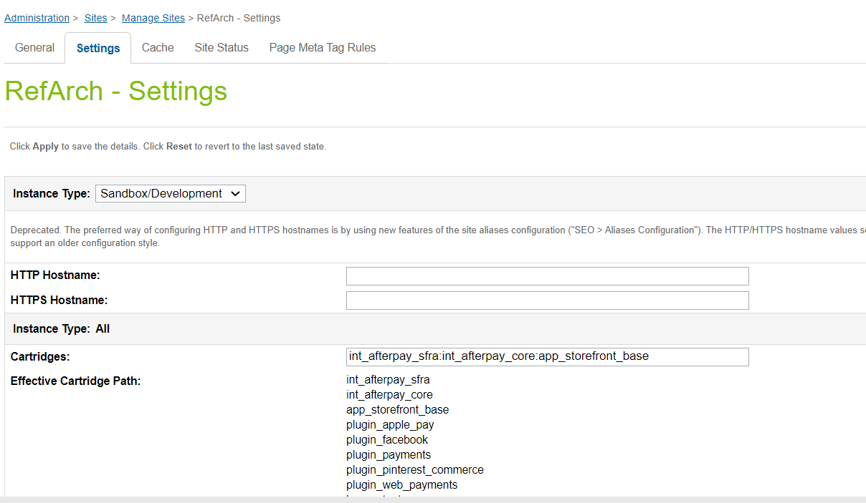

1. Click Apply.
2. To activate the cartridge for the Sandbox/Development/Production instances repeat steps 4 and 5 after selecting the appropriate instance from the Instance Type dropdown menu.
3. Repeat steps 3 to 6 for each site that is to use Afterpay.

### Set Afterpay Custom Site Preferences

After installing the cartridge, the following new configuration options will be available in the **Business Manager**.

In the Business Manager, go to **Merchant Tools > Site Preferences > Custom Preferences > Integration_Afterpay**

| Site Preference | Description | Default |
| --- | --- | --- |
| Enable CashAppPay  (enableCashAppPay) | The field determines if the Cash App Pay is enabled / disabled in the cartridge.  **Note : If you are setting this preference to true, please make sure:**   * **Cash App integration is actually enabled for you in the portal** * **Enable Afterpay is also true. Cash App Pay won’t load without it on the checkout page**. | False |

### 

### Set Payment Methods

Merchant Tools > Ordering > Import & Export > Upload the “payment-methods.xml” from the metadata folder > Import the xml. A payment method with the names AFTERPAY and CASHAPPPAY are available.

### Set Afterpay Payment Processors

Merchant Tools > Ordering > Payment Processors > Click New Give a unique ID for the processors:

* “AFTERPAY_CREDIT” Description: **“**Pay By Installment” and click Apply
* “CASHAPP_CREDIT” Description: “Cash App Pay and” click apply

### Add CashApp Image to Payment Method

In order to display the Afterpay image on the site the image needs to be added to your site.

* Merchant Tools > Ordering > Payment Methods
* Select the payment method with ID CASHAPPPAY (depending on target region) and locate the image attribute and upload the image included in the cartridge int_afterpay_sfra/cartridge/static/default/images/cashapppay-logomark1x.png

### Set SFCC(Demandware) Service

Administration > Operations > Services > Credentials > afterpay.http.defaultcredentials > Details > Credentials tab and select required service and enter the account details.

| URL | **Sandbox**  https://global-api-sandbox.afterpay.com/v2/  **Production**  https://global-api.afterpay.com/v2/ |
| --- | --- |
| User | Enter the Merchant ID provided by Afterpay |
| Password | Enter the Secret Key provided by Afterpay |

# 

# Testing

## Cash App Pay Checkout Flow

If you’ve enabled Cash App Pay, you would be able to see the Cash App Pay payment option on the checkout page. A consumer needs to have a CashApp application installed on their phone that scans the QR code on the popup..  
  
  
Checkout Page

For an eligible order, Cash App Pay will appear as a payment option on the Checkout.

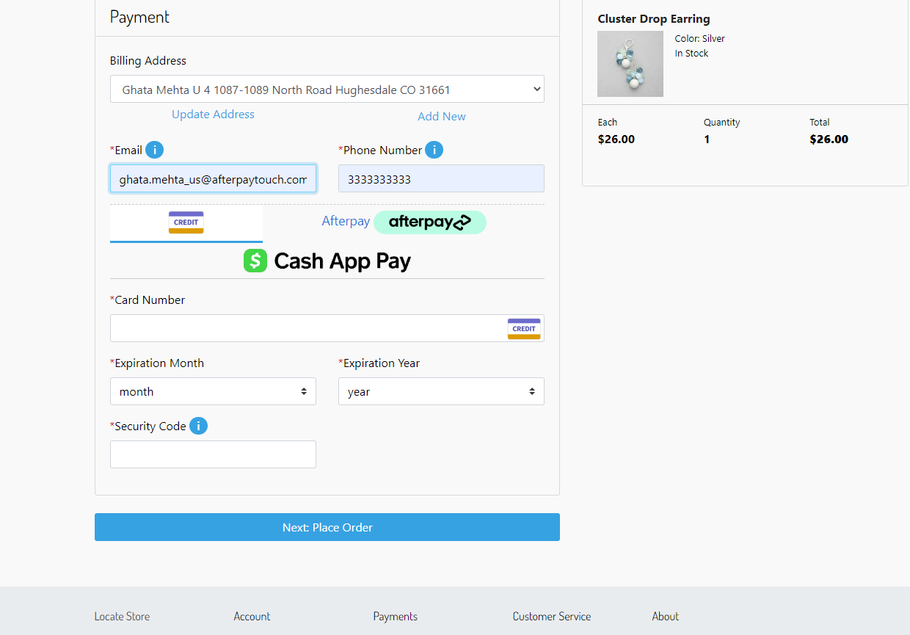

When you click on the Cash App Pay, a “Cash App Pay” button will be rendered.

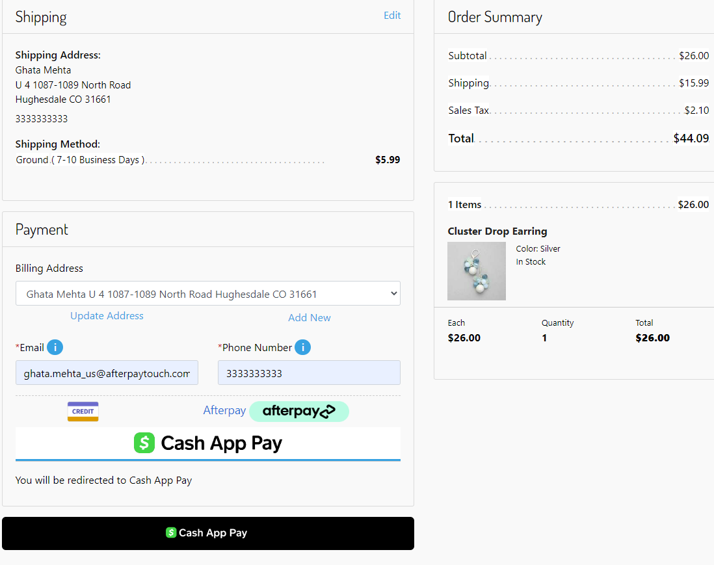

When you click on the “Cash App Pay” button, a popup will open with a QR code.

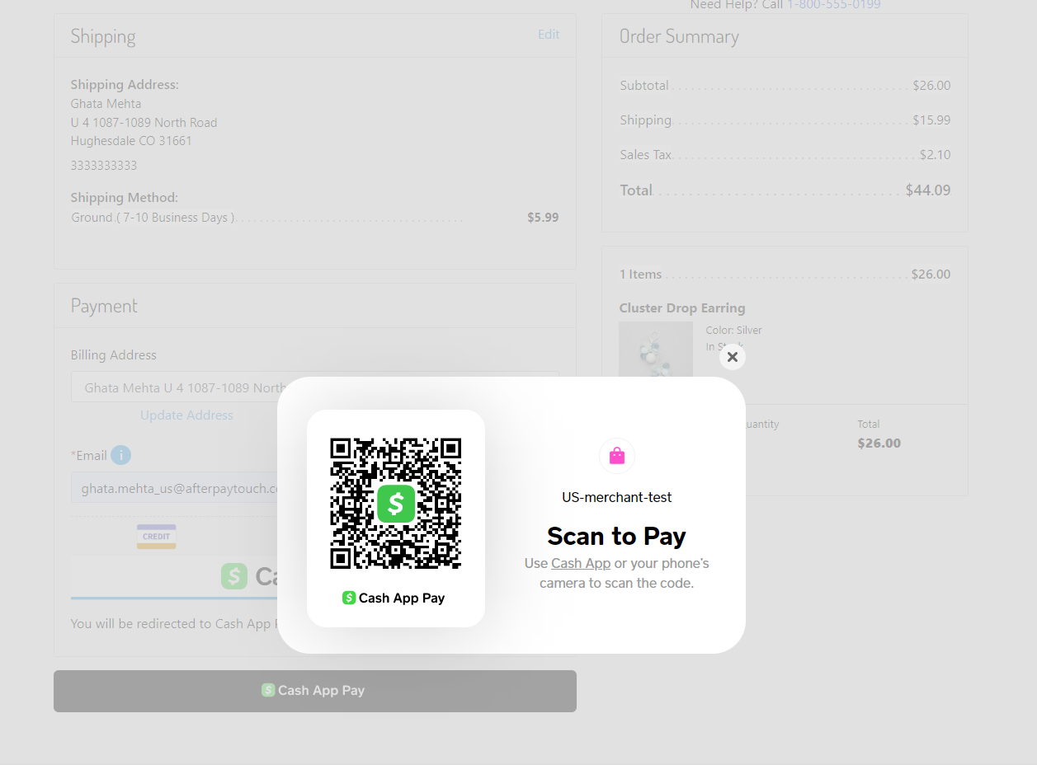

On your phone, you scan the QR code with the Cash App Application, when prompted you either accept/decline the payment.

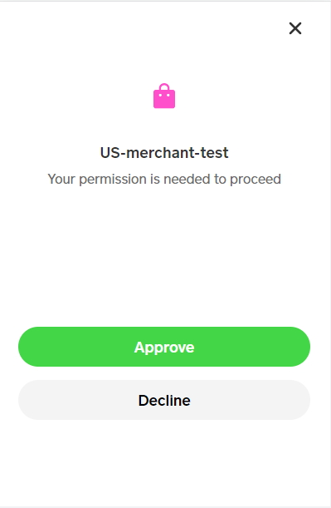

On Accepting, Cash App Pay will process the payment and you will be redirected to the order confirmation page.

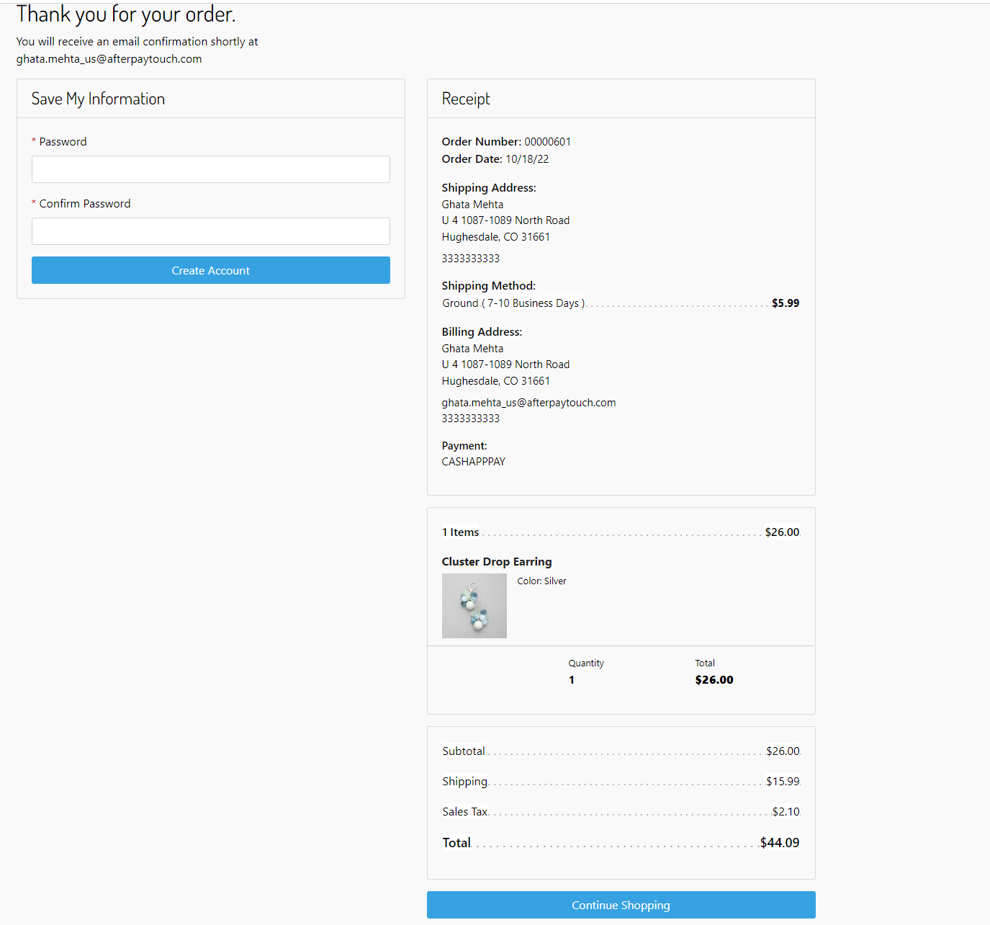

# 

Order in Business Manager

You can see the Order in Merchant Tools > Ordering > Orders

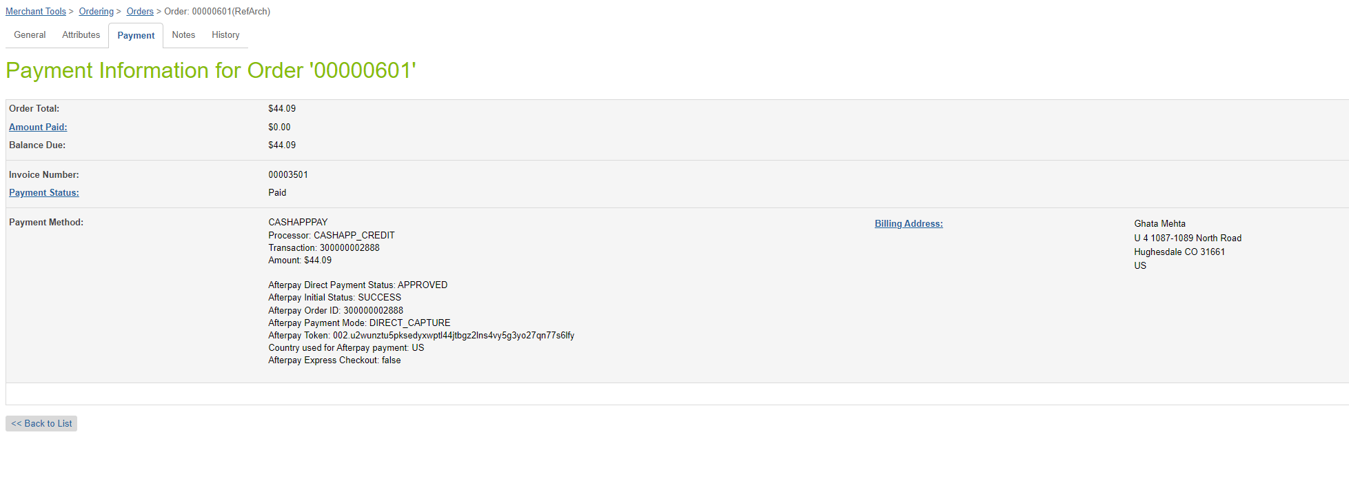

# 

# Operations / Maintenance

## Data Storage

Some additional custom attributes are stored against system objects. The following table lists these attributes and their uses, other than Site Preferences (which are listed under section 3.3.2).

| Object | Attribute | Type | Description |
| --- | --- | --- | --- |
| Order | Cash App Pay Payment Method  (isCashAppPayOrder) | Boolean | Flags the order as an Cash App Pay order |

## Support

For support, please contact your Afterpay account contact.